ENGINEERING CHEMISTRY
UNIT I WATER
Hardness of water – units and calcium carbonate equivalent. Determination of hardness of water – EDTA method. Disadvantages of hard water – boiler scale and sludge, caustic embrittlement, priming and foaming and boiler corrosion. Water softening methods – internal and external conditioning - lime-soda process, zeolite process and ion exchange process. Desalination – reverse osmosis and electrodialysis.
UNIT II POLYMERS
Classification, types of polymerization reactions – mechanism of radical, ionic and Ziegler-Natta polymerizations. Polymer properties – chemical resistance, crystalinity and effect of temperature. Mn and Mw. Thermoplastics and thermosets. Preparation, properties and uses of PVC, TEFLON, Nylons, Bakelite, polyurethane, Rubbers-vulcanization, synthetic rubber, buna S, buna N, silicone and butyl rubber. Conducting polymers – classification and applications. Polymer composites – FRP – laminar composites. Moulding constituents of plastic, Moulding techniques – Compression, Injection, Transfer and Extrusion moulding.
UNIT III ELECTROCHEMICAL CELLS
Galvanic cells, single electrode potential, standard electrode potential, electromotive series. EMF of a cell and its measurement. Nernst equation. Electrolyte Concentration cell. Reference electrodes – Hydrogen, Calomel, Ag/AgCl and Glass electrodes. Batteries – Primary and secondary cells, laclanche cell, lead acid storage cell and Ni-Cd battery and alkaline battery. Fuel cells – H₂-O₂ fuel cell.
UNIT IV CORROSION AND ITS CONTROL
Chemical and Electrochemical corrosion – Galvanic series - galvanic, pitting, stress and concentration cell corrosion. Factors influencing corrosion – corrosion control methods – cathodic protection and corrosion inhibitors. Protective coating – types of protective coatings – metallic coating-tinning and galvalizing, cladding, electroplating and anodizing.
UNIT V PHASE RULE
Definition and derivation of phase rule. Application to one component system – water and sulphur systems. Thermal analysis, condensed phase rule. Two component alloy systems – Pb-Ag, Cu-Ni and Mg-Zn systems.
TEXT BOOKS: 1. P.C. Jain and Monika Jain, Engineering Chemistry, Dhanpat Rai & Sons, New Delhi, 2004. 2. N. Krishnamurthy, P. Vallinayagam and D. Madhavan, Engineering Chemistry, 2nd edition. PHI Learning Pvt. Ltd., New Delhi, 2008.
REFERENCE BOOKS: 1. S.S. Dara, A Textbook of Engineering Chemistry, S. Chand and Co., Ltd. New Delhi. 2. B.K. Sharma, Engineering Chemistry, 3rd edition, Krishna Prakashan Media Ltd., Meerut, 2001.
UNIT 1 WATER
PART - A
1. Define Parts per million.
It is number of parts of calcium carbonate equivalent hardness per million (10⁶) parts of water. 1 ppm = 1 part of CaCO₃ eq. hardness in 10⁶ parts of water.
2. List the difference between temporary and permanent hardness. (May18, 19, Nov 19, Sep 20)
Temporary hardness | Permanent hardness
(i) Presence of dissolved carbonates and bicarbonates of Ca²⁺, Mg²⁺ and heavy metals and carbonate of iron.  (ii) It can be removed by boiling.  (iii) Technical methods are not required to remove hardness. | Presence of dissolved chloride and sulphates of calcium, magnesium and other heavy metals.  It can’t be removed by boiling.  Lime-Soda process, Zeolite method and Ion exchange process are employed to remove hardness.

3. Why the hardness of water is expressed in CaCO₃ equivalent? (Jan 11, Jan 14, May 15, Nov 16)

Hardness of water is expressed in CaCO₃ equivalent, since its molecular weight is 100 and equivalent weight is 50. Moreover, CaCO₃ is most insoluble salt that can be precipitated in water treatment.

4. Mention some disadvantages of hard water in domestic and industrial area. (Nov 19)
(i) Bathing: Hard water does not lather freely with soap solution, but produces sticky scum on bath tub and body.
(ii) Drinking: Hard water causes bad effect in our digestive system. Moreover, possibility of forming calcium oxalate crystals in urinary tracks is increased.

(iii) Laundry: Hard water in laundry causes much of the soap used in washing to go as waste. Iron salts may even cause coloration of clothes.
(iv) Pharmaceutical: Product is undesirable due to presence of hard water.

Disadvantages of using hard water in boilers
When water from natural sources having hardness is fed directly to boilers then it causes many troubles to boiler such as,
- Sludge and Scale formation
- Caustic embrittlement
- Boiler Corrosion
- Priming and Foaming.
5. Differentiate between sludge and scale. (May 13, Jan 14, May 16, Nov 19, Sep 20)
Sludge | Scale
(i) Sludge is loose, slimy and non-adherent precipitate.  (ii) Main substances are MgCl₂, MgCO₃ and MgSO₄.  (iii) Disadvantages are poor conductors of heat and excess of sludge formation decreases efficiency of boiler. | Scale is hard adherent coating.  Main substances are Ca(HCO₃)₂ and CaSO₄.  Disadvantages are decrease in efficiency of boiler and if any crack developed in scale, lead to explosion.

6. What is meant by Caustic embrittlement? (May 14, Nov 19, Sep 20)

Caustic embrittlement is a type of boiler corrosion, caused by using highly alkaline water in boiler. During softening of water by lime-soda process, free Na₂CO₃ is usually present in small amount in softened water. In high pressure boilers, Na₂CO₃ decomposes to give sodium hydroxide and carbon dioxide, which makes boiler water caustic.

Na₂CO₃ + H₂O 2 NaOH + CO₂
NaOH containing water flows into the minute hair-cracks, always present in the inner side of boiler, by capillary action. Here, water evaporates and dissolved caustic soda concentration increases progressively. This caustic soda attacks surrounding area, thereby dissolving iron of boiler as sodium ferroate. This causes embrittlement of boiler.

7. How Caustic embrittlement can be avoided? (Nov 11, Jan 13, Nov 19)
(i) By using sodium phosphate or sodium sulphate as softening reagent, instead of sodium carbonate.
(ii) By adding tannin or lignin to boiler water, since these blocks hair cracks, thereby preventing infiltration of caustic soda.
8. What is Calgon? What is its role in water treatment? (May 14)
Calgon is sodium hexa meta phosphate (NaPO₃)_{6.} It prevents the scale and sludge formation by forming soluble complex compound with CaSO₄.
9. What are Priming and Foaming in boilers? (Nov 16, May 17, Nov 19)
Priming
When a boiler is producing steam rapidly, tiny particles of liquid water are carried along with steam. This process of wet steam formation is called priming. Priming is caused by the presence of large amount of dissolved solids, high steam velocities, sudden boiling, improper boiler design and sudden increase in steam production rate.
Foaming
Foaming is the production of persistent foam or bubbles in boilers, which do not break easily. It is due to the presence of substances like oils in boiler water.

10. Why buffer is added in the estimation of hardness of water by EDTA method? (May 15, Jan 16)

EDTA titration is carried out using Eriochrome black-T indicator, which gives end point when pH of water sample is maintained around 10.
11. What are Zeolites? (Nov 19)
Zeolites are hydrated sodium alumino silicates, capable of exchanging reversibly its sodium ions for hardness producing ions in water.
Chemical structure of sodium zeolite may be represented as,
Na₂O. Al₂O₃. x SiO₂. y H₂O where x = 2 – 10 and y = 2 – 6.
12. How is exhausted zeolite softener bed regenerated? (May 14, Nov 19)
Exhausted zeolite softener bed is regenerated by treating with concentrated (10%) brine (NaCl) solution.
13. What is Desalination? What are its uses? (Nov 18)
Process of removing common salt (NaCl) and other minerals from water is known Desalination. Water is desalinated in order to convert salt water to fresh water which is suitable for human consumption or irrigation.
14. What is meant by Reverse Osmosis? (May 14, Jan 15)
Reverse Osmosis is a filtration method that removes large molecules and ions from solutions by applying pressure to solution when it is on one side of a selective membrane.
The solute is retained on pressurized side of membrane and pure solvent is allowed to pass to other side. To be "selective", this membrane should not allow large molecules or ions through pores, but should allow smaller components of solution to pass freely.

15. How does Eriochrome Black T function as indicator in EDTA titration? (May 17)
In order to determine the equivalent point (i.e., just completion of metal-EDTA complex formation), indicator Eriochrome Black T or EBT is employed which form unstable wine-red complex with Cu²⁺ (metal ions i.e., M-EBT). During the curse of titration against EDTA it forms stable M-EDTA complex and releasing free EBT. Thus change of wine red to blue marks the end point of the titration.

16. Why in water softened by Zeolite process unfit for use in Boilers? (Nov 17)
In this method only replaces Ca²⁺/Mg²⁺ ions by Na⁺ ions, but leaves all the anions (like HCO₃⁻ and CO₃²⁻ ) as such. These causes corrosion and caustic embrittlement.

PART - B

1. Explain the determination of hardness of water by EDTA method. (May 12, Jan 13, May 13, May 14, Jan 15, Nov 16, May 18, Nov 18, Nov 19)
Principle
Hardness of water is due to the dissolved bicarbonates, carbonates (Temporary hardness) and chlorides, sulphates of calcium and magnesium (Permanent hardness).
Ethylene Diamine Tetra Acetic acid (EDTA) is a tetra carboxylic acid. This method is based upon the fact that EDTA forms remarkable stable complexes with metals, particularly di and polyvalent metals and it can be represented as,
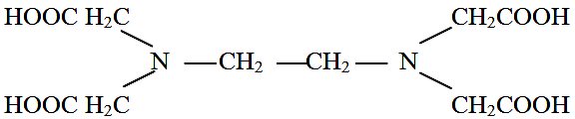
EDTA does not dissolve completely in water and hence disodium salt is used to estimate hardness producing ions present in hard water. EDTA reacts with Ca and Mg ions forming stable complexes. The indicator used in this titration is Eriochrome Black–T. It is a tribasic acid dye having blue colour at about pH 10.
When a drop of indicator is added to hard water sample containing Ca and Mg ions at pH 10, Mg – indicator complex will be formed producing red colour. Now to this solution, if EDTA solution is gradually added, it will remove Ca ions first because Ca – EDTA complex being more stable.
When all calcium ions are used up, excess EDTA if added will snatch Mg²⁺ ions from Mg – indicator complex (because Mg - EDTA complex is more stable than Mg – indicator complex) leaving the trivalent indicator ion free, which being blue in colour will produce blue colour solution. Thus a colour change from red to blue will indicate the end point.
The reactions involved are,
Metal ions + EBT Metal ions – EBT
(Ca²⁺ / Mg²⁺) (indicator) (weak complex, wine red colour)
Metal ions – EBT + EDTA Metal ions – EDTA + EBT
(unstable, wine red colour) stable complex blue colour
Titration
Standardization of EDTA solution: Burette is filled with EDTA solution. 50 mL of standard hard water is pipetted in a conical flask. 10 mL of buffer solution and 3 drops Eriochrome Black-T indicator are added and it is titrated with EDTA solution, till wine red color changes to blue. Let the volume used be V₁ mL.
Titration of temporary hard water: 50 mL of water sample is titrated with EDTA. Let the volume used be V₂ mL.
Titration of Permanent hardness: 250 mL of water sample is taken in a large beaker and it is boiled till volume reduced to about 50 mL. It is filtered and precipitate is washed with distill water, by collecting filtrate and washings in 250 mL measuring flask. It is made up to 250 mL with distilled water. Then 50 mL of boiled water sample is titrated with EDTA. Let the volume be V₃ mL.
Calculations
50 mL of standard hard water = V₁ mL of EDTA
50 x 1 mg of CaCO₃ = V₁ mL of EDTA
1ml of EDTA = 50 / V₁ mg of CaCO₃ eq
Now 50 mL of given hard water = V₂ mL of EDTA
= V₂ x (50 / V₁) mg of CaCO₃ eq
1L (1000 mL) of given hard water = 1000 V₂ / V₁ mg of CaCO₃ eq
Total hardness of water = 1000 V₂ / V₁ mg/L or ppm
Now 50 ml of boiled water = V₃ mL of EDTA
= V₃ x (50 / V₁) mg of CaCO₃ eq
1000 mL (1L) of boiled water = 1000 V₃ / V₁ mg of CaCO₃ eq
Permanent hardness = 1000 V₃ / V₁ ppm
Temporary hardness = [Total – Permanent] hardness
= 1000 V₂ – V₃
V₁ V₁
= 1000 (V₂ – V₃) ppm
V₁
2. Write a note on Scale and Sludge formation in boilers. (Nov 11, May 11, Nov 12, May 14, Jan 16, Nov 16, Nov 17, Sep 20)

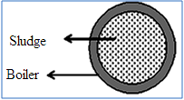
Sludge

Sludge is a soft, loose and slimy precipitate formed within the boiler. Sludge can easily be scrapped off with a wire brush. It is formed at comparatively colder portions of boiler and collects, where the flow rate is slow or at bends. Sludge is formed by substances which have greater solubility in hot water than in cold water.

E.g. MgCO₃, MgCl₂, CaCl₂ and MgSO₄.

Disadvantages of sludge formation
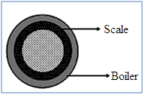
- Sludges are poor conductor of heat, so they tend to waste a portion of heat generated.
- If sludges are formed along with scales, then sludge gets entrapped in scale and both get deposited as scales.
- Excessive sludge formation disturbs working of boiler. It settles in regions of poor water circulation such as pipe connection, plug opening, etc. thereby causing even choking of pipes.

Prevention of sludge formation
- By using well softened water.
- By frequent blow down operation, i.e., drawing off portion of concentrated water.

Scales
Scales are hard deposits, which stick very firmly to the inner surfaces of boiler. Scales are difficult to remove, even with help of hammer and chisel. Scales are the main sources of boiler troubles.

Formation of scales may be due to,

(i) Decomposition of calcium bicarbonate
Ca(HCO₃)₂ CaCO₃ + H₂O + CO
However, scale composed of calcium carbonate is soft and it is the main cause of scale formation in low pressure boilers. But in high pressure boilers, CaCO₃ is soluble.
CaCO₃ + H₂O Ca(OH)₂ + CO₂

(ii) Deposition of calcium sulphate
Solubility of calcium sulphate in water decreases with rise of temperature. In other words, CaSO₄ is soluble in cold water, but almost completely insoluble in super heated water. Consequently, CaSO₄ gets precipitated as hard scale on heated portions of boiler which is the main cause of scales in high pressure boilers. But calcium sulphate scale is quite adherent and difficult to remove, even with help of hammer and chisel.

(iii) Hydrolysis of magnesium salts
Dissolved magnesium salts undergo hydrolysis at prevailing high temperature inside the boiler forming magnesium hydroxide precipitate, which forms a soft type of scale.
MgCl₂ + 2 H₂O Mg(OH)₂ + 2 HCl

(iv) Presence of silica
Silica, even present in small quantities, deposits as calcium silicate and magnesium silicate. These deposits stick very firmly on the inner side of boiler surface and are very difficult to remove. One important source of silica in water is the sand filter.

Disadvantages of scale formation
(i) Wastage of fuel: Scales have a low thermal conductivity, so the rate of heat transfer from boiler to inside water is greatly decreased. In order to provide a steady supply of heat to water, excessive or over heating is done and this causes increase in fuel consumption. Wastage of fuel depends upon thickness and nature of scale.
(ii) Lowering of boiler safety: Due to scale formation, over heating of boiler is done in order to maintain a constant supply of steam.
Overheating makes the boiler material softer and weaker and this causes distortion of boiler tube and also makes the boiler unsafe to bear the pressure of steam, especially in high pressure boilers.
(iii) Decrease in efficiency: Scales may sometimes deposit in valves and condensers of boiler and choke them partially. This results in decrease in efficiency of the boiler.
(iv) Danger of explosion: When thick scales crack, due to uneven expansion, water comes suddenly in contact with overheated iron plates. This causes in formation of a large amount of steam suddenly and high pressure is developed, which may even cause explosion of boiler.

Removal of Scales
- With help of scraper or piece of wood or wire brush, if they are loosely adhering.
- By giving thermal shocks, i.e., heating the boiler and then suddenly cooling with cold water, if they are brittle.
- Dissolving them by adding chemicals such as HCl and EDTA.
- By frequent blow-down operation, if scales are loosely adhering.

3. Explain various internal treatment processes to prevent the scale formation. (Jan 11, May 11, May 12, May 15, Jan 16, May 17)
This is also called as sequestration, an ion is prohibited to exhibit its original character by complexing or converting it into other more soluble salt by adding appropriate reagent.
An internal treatment is accomplished by adding a proper chemical to boiler water itself. This is either to precipitate scale forming impurities in the form of sludges, which can be removed by blow down operation or to convert them into compounds, which will stay in dissolved form in water and thus do not cause any harm.
Internal treatment methods are, generally followed by blow-down operation, so that accumulated sludge is removed. Important methods are,
(i) Colloidal conditioning: In low pressure boilers, scale formation can be avoided by adding organic substances like kerosene, tannin, agar-agar etc., which get coated over scale forming precipitates, thereby yielding non sticky and loose deposits, which can easily be removed by pre determined blow down operations.
(ii) Phosphate conditioning: In high pressure boilers, scale formation can be avoided by adding sodium phosphate. This reacts with hardness of water forming non adherent and easily removable, soft sludge of calcium and magnesium phosphates, which is removed by blow-down operation.
3 CaCl₂ + 2 Na₃PO₄ Ca₃(PO₄)₂ + 6 NaCl
Phosphates employed for this purpose are sodium dihydrogen phosphate (acidic), disodium hydrogen phosphate (weakly alkaline) and trisodium phosphate (alkaline).
(iii) Carbonate conditioning: In low pressure boilers, scale formation can be avoided by adding sodium carbonate to boiler water, when CaSO₄ is converted into calcium carbonate in equilibrium.
CaSO₄ + Na₂CO₃ CaCO₃ + Na₂SO₄
Consequently, deposition of CaSO₄ as scale does not take place and calcium is precipitated as loose sludge of CaCO₃, which can be removed by blow down operation.
(iv) Calgon conditioning: It involves in adding calgon [sodium hexa meta phosphate (NaPO₃)₆ to boiler water. It prevents the scale and sludge formation by forming soluble complex compound with CaSO₄.
Na₂[Na₄(PO₃)₆] 2 Na⁺ + [Na₄P₆O₁₈]²⁻
2 CaSO₄ + [Na₄P₆O₁₈]²⁻ [Ca₂P₆O₁₈]²⁻ + 2 Na₂SO₄
(v) With sodium aluminate: Sodium aluminate gets hydrolysed yielding NaOH and gelatinous precipitate of aluminium hydroxide.
NaAlO₂ + 2 H₂O NaOH + Al(OH)₃
Sodium hydroxide formed, precipitates some of magnesium as Mg(OH)₂.
MgCl₂ + 2 NaOH Mg(OH)₂ + 2 NaCl
Flocculent precipitate of Mg(OH)₂ plus Al(OH)₃ produced inside boiler, entraps finely suspended colloidal impurities, including oil drops and silica. Precipitates can be removed by pre determined blow down operation.
(vi) Electrical conditioning: Sealed glass bulbs, containing mercury connected to a battery are set rotating in the boiler. When water boils, mercury bulb emit electrical discharges, which prevents scale forming particles to adhere together to form scale.
(vii) Radioactive conditioning: Tablets containing radioactive salts are placed inside boiler water at few points. The radiations emitted by these salts prevent scale formation.

4. Write note on Caustic Embrittlement. (May 11, May 12, Jan 14, May 15, 17, Nov 19)
Caustic Embrittlement is a type of boiler corrosion, caused by using highly alkaline water in boiler. During softening process by lime-soda process, free Na₂CO₃ is usually present in small proportion in the softened water. In high pressure boilers, Na₂CO₃ decomposes to give sodium hydroxide and carbon dioxide which makes the boiler water caustic.
Na₂CO₃ + H₂O 2 NaOH + CO₂
NaOH formed flows into minute hair-cracks, always present in inner side of boiler, by capillary action. Here, water evaporates and dissolved caustic soda concentration increases progressively. This caustic soda attacks surrounding area, thereby dissolving iron of boiler as sodium ferroate.
This causes embrittlement of boiler parts, particularly stressed parts like bends, joints, rivets, etc., causing even failure of the boiler. Caustic cracking can be explained by considering the following concentration cell:
Iron at rivets (+) Concentrated NaOH Dilute NaOH (– ) Iron at plian
bends, joints solution solution surfaces
Iron surrounded by dilute NaOH becomes cathodic side and with concentrated NaOH becomes anodic part, which is consequently corroded.

Caustic embrittlement can be avoided by,
- sodium phosphate as softening reagent, instead of sodium carbonate.
- adding tannin or lignin to boiler water, since these blocks hair cracks, thereby preventing infiltration of caustic soda solution.
- adding sodium sulphate to boiler water which blocks hair cracks, thereby preventing infiltration of caustic soda solutions.

5. Write a note on Boiler corrosion. (Nov 10, May 12, May 15, May 17, May 18)
Boiler corrosion is decay of boiler material by chemical or electrochemical attack of its environment. Reasons for boiler corrosion are,

(a) Dissolved oxygen

Water contains about 8 ml of dissolved oxygen per litre at room temperature. Dissolved oxygen in water, in presence of prevailing high temperature, attacks boiler material.
2 Fe + 2 H₂O + O₂ 2 Fe (OH)₂
4 Fe (OH)₂ + O₂ 2 [Fe₂O₃. 2 H₂O]

Removal of dissolved oxygen
(i) By adding sodium sulphite or hydrazine or sodium sulphide.
2 Na₂SO₃ + O₂ 2 Na₂SO₄
(ii) By mechanical deaeration, i.e., spraying water in a perforated plate-fitted tower, heated from sides and connected to vacuum pump. High temperature, low pressure and large exposed surface reduce dissolved oxygen in water.

(b) Dissolved carbon dioxide
Carbonic acid (H₂CO₃) has a slow corrosive effect on boiler material. Carbon dioxide is also released inside the boiler, if water used for steam generation contains bicarbonate.
Mg(HCO₃)₂ MgCO₃ + H₂O + CO₂

Removal of CO₂

(i) By adding calculated quantity of ammonia.
2 NH₄OH + CO₂ (NH₄)₂CO₃ + H₂O

(ii) By mechanical deaeration process.

(c) Acids from dissolved salts
Water containing magnesium salts liberate acids on hydrolysis.
MgCl₂ + 2 H₂O Mg(OH)₂ + 2 HCl
Liberated acid reacts with iron in chain like reactions producing HCl again and again.
Fe + 2 HCl FeCl₂ + H₂
FeCl₂ + 2 H₂O Fe(OH)₂ + 2 HCl
Thus, presence of a small amount of MgCl₂ will cause corrosion of iron to a large extent.

6. Explain the Lime - Soda process. (Nov 10, Nov 11, Jan 13, May 13, May 16, Nov 19)
In Lime–Soda process, soluble calcium and magnesium salts in water are chemically converted into insoluble compounds, by adding calculated amounts of lime [Ca(OH)₂] and soda [NaCO₃]. Calcium carbonate and magnesium hydroxide so precipitated are filtered off.
Function of Lime
Reactions taking place during addition of lime are,
(i) Lime precipitates temporary calcium and magnesium hardness.
Ca(HCO₃)₂ + Ca(OH)₂ 2 CaCO₃ + 2 H₂O
(ii) Lime precipitates the permanent magnesium hardness.
MgCl₂ + Ca(OH)₂ Mg(OH)₂ + CaCl₂
Lime requirement
Masses of hardness producing substances are converted to CaCO₃ equivalents. Thus, 100 parts CaCO₃ are equivalent to 74 parts of lime.
Therefore, amount of lime required is,
Lime = 74 / 100 [Temp Ca²⁺ + (2 x Temp Mg²⁺) + Perm (Mg²⁺ + Fe²⁺ + Al³⁺) + CO₂ + H⁺ + HCO₃– – NaAlO₂] mg/L
all in terms of CaCO₃ equivalent.
Function of Soda
Soda (Na₂CO₃) reacts with soluble permanent hardness of calcium present originally in water and permanent calcium hardness introduced during reactions of lime with HCl, MgCl₂, MgSO₄, Al₂(SO₄)₃, FeSO₄, etc.
CaCl₂ + Na₂CO₃ CaCO₃ + 2 NaCl
Soda requirement
Masses of hardness producing substances are converted to CaCO₃ equivalents. Thus 100 parts CaCO₃ are equivalent to 106 parts of lime.
Thus the amount of Soda required is,
Soda = 106 / 100 [Perm Ca²⁺ + Perm (Mg²⁺ + Fe²⁺ + Al³⁺) + H⁺ – HCO^{3–}] mg/L
all in terms of CaCO₃ equivalent.

There are two types of Lime – Soda process.

(i) Cold lime-soda process (Jan 14)
In this method, calculated quantity of chemicals, lime and soda are mixed with water at room temperature. The precipitates formed are finely divided, so they do not settle down easily and cannot be filtered easily.
Consequently, it is essential to add small amounts of coagulant like alum, aluminium sulphate, sodium aluminate, etc., which hydrolyses to flocculent, gelatinous precipitate of aluminium hydroxide, and entraps fine precipitates. Use of sodium aluminate as coagulant also helps in removal of silica as well as oil, if present in water.
NaAlO₂ + 2 H₂O NaOH + Al(OH)₃
Cold L-S process provides water of residual hardness of 50 - 60 ppm.
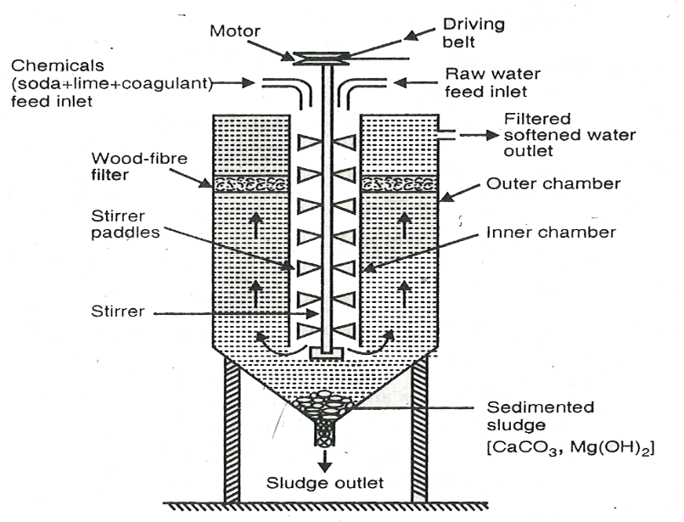Cold Lime-Soda Softener
Method
Raw water and calculated quantities of chemicals (lime + soda + coagulant) are fed from top into inner vertical circular chamber, fitted with a vertical rotating shaft carrying a number of paddles. As raw water and chemicals flow down, there is a vigorous stirring and continuous mixing, whereby softening of water takes place. When softened water comes into outer co-axial chamber, it rises upwards. The heavy sludge or precipitated floc settles down in the outer chamber as softened water reaches up. Softened water then passes through a filtering media made of wood fibres to ensure complete removal of sludge. Filtered soft water finally flows out continuously through outlet at the top. Sludge settling at the bottom of outer chamber is drawn off occasionally.

(ii) Hot lime-soda process
Hot Lime-Soda Softener
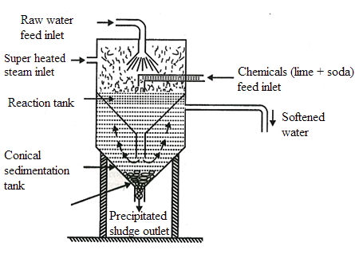
It involves in treating water with softening chemicals at temperature from 80 to 150°C.
Method
Hot lime-soda plant consists essentially of three parts:
(a) a reaction tank, in which raw water, chemicals and steam are thoroughly mixed
(b) a conical sedimentation vessel, in which sludge settles down
(c) a sand filter which ensures complete removal of sludge from the softened water.
Since hot process is operated at a temperature close to the boiling point of solution, it has many advantages over cold Lime-Soda process.
Advantages of Hot Lime–Soda Process
- Reaction proceeds faster and softening capacity is increased to many fold.
- Precipitate and sludge formed settle down rapidly and hence, no coagulant is needed.
- Much of dissolved gases like CO₂ and air are driven out of water.
- Viscosity of softened water is lower, so filtration of water becomes much easier, in-turn increases filtering capacity of filters.
- Hot lime-soda process produces water of lower residual hardness of 15 to 30 ppm.

Advantages of Lime–Soda process
(i) It is very economical.
(ii) If this process is combined with sedimentation with coagulation, lesser amounts of coagulants shall be needed.
(iii) It increases pH value of treated water and corrosion of distribution pipes is reduced.
(iv) Besides removal of hardness, quantity of minerals is reduced.
(v) To certain extent, iron and manganese are also removed from water.
(vi) Due to alkaline nature of treated water, amount of pathogenic bacterias in water is considerably reduced.

Disadvantages of L-S process
(i) For efficient and economical softening, careful operation and supervision is required.
(ii) Disposal of large amount of sludge/insoluble precipitate is a problem.
(iii) It removes hardness only upto 15 ppm, which is not good for boilers.

7. Explain Zeolite or Permutit process. (Nov 10, Jan 11, May 11, Nov 11, Jan 14, May 15, Nov 16, Nov 18, May 19, Nov 19)
Chemical structure of sodium zeolite may be represented as,
Na₂O. Al₂O₃. x SiO₂. y H₂O where x = 2 - 10 and y = 2 - 6.
Zeolite is hydrated sodium alumino silicate, capable of exchanging reversibly its sodium ions for hardness producing ions in water. Zeolites are also known as permutits. Zeolites are of two types. They are,
(i) Natural zeolites are non-porous.
E.g. Natrolite. Na₂O. Al₂O₃. 4 SiO₂. 2 H₂O.
(ii) Synthetic zeolites are porous and possess gel structure. They are prepared by heating together china clay, feldspar and soda ash.
Such zeolites possess higher exchange capacity per unit weight than natural zeolites.
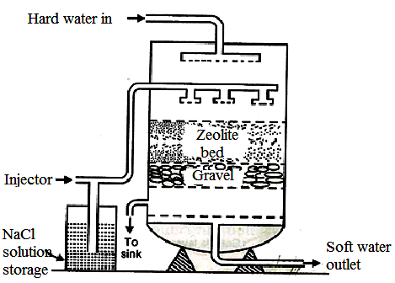
Zeolite Softener

Process
For softening of water by zeolite process, hard water is percolated at a specified rate through a bed of zeolite (Ze), kept in a cylinder.
Hardness causing ions like Ca²⁺ and Mg²⁺ are retained by zeolite as CaZe and MgZe respectively; while the outgoing water contains sodium salts. Reactions taking place during the softening process are,
Na₂Ze + Ca(HCO₃)₂ CaZe + 2 NaHCO₃
Na₂Ze + CaCl₂ CaZe + 2 NaCl

Regeneration
After some time, zeolite is completely converted into calcium and magnesium zeolites and it ceases to soften water, i.e., it gets exhausted.
At this stage, supply of hard water is stopped and the exhausted zeolite is reclaimed by treating bed with concentrated (10%) brine (NaCl) solution.
CaZe + 2 NaCl Na₂Ze + CaCl₂
Washings containing CaCl₂ and MgCl₂ are led to drain and the regenerated zeolite bed thus obtained is used again for softening purpose.

Limitations
(i) If supplied water is turbid, suspended matter must be removed by coagulation before water is admitted to zeolite bed; otherwise turbidity will clog pores of zeolite bed and making it inactive.
(ii) If water contains large quantities of coloured ions such as Mn²⁺ and Fe²⁺, they must be removed first. Because these ions produce manganese and iron zeolites, which cannot be easily regenerated.
(iii) If mineral acids present in water, they destroy zeolite bed. Therefore they must be neutralized with soda, before admitting water to the zeolite softening plant.

Advantages
(i) Removes hardness efficiently and 10 ppm hardness is produced.
(ii) Equipment used is compact and occupies a small space.
(iii) No impurities are precipitated and there is no sludge formation.
(iv) It automatically adjusts for variation in hardness of incoming water.
(v) It is quite clean and requires less time for softening.
(vi) Process requires less skill for maintenance as well as operation.

Disadvantages

(i) Treated water contains some quantity of sodium salts which cannot be used for boiler.
(ii) This method only replaces calcium and magnesium ions by sodium ions, but leaves all acidic ions like bicarbonate and carbonate as such in the softened water.
(iii) When such softened water is used in boilers for steam generation, sodium bicarbonate decomposes producing CO_{2.} This causes corrosion and sodium carbonate hydrolyses to sodium hydroxide, which causes caustic embrittlement.
(iv) High turbidity water cannot be treated by this process, since fine impurities get deposited on zeolite bed and making the bed inactive.

8. Compare Permutit process with Lime–Soda process. (Sep 20)
Zeolite or Permutit process | Lime–Soda process
(i) This is an exchange process.  (ii) Residual hardness is 10–15 ppm.  (iii) Treated water contains larger amount of sodium salts.  (iv) Plant occupies less space and operation expenses are lower.  (v) Plant & material cost is higher.  (vi) Cannot be used for acidic water, as zeolite undergoes disintegration.  (vii) Raw water must be free from suspended matter; otherwise pores of permutit material are blocked and bed loses its exchange capacity.  (viii) Operated under pressure and can be made fully automatic.  (ix) No problem of settling, coagulation, filtration and removal of the sludges and precipitates.  (x) Control test comprises only in checking hardness of treated water.  (xi) Treated water contains more dissolved solids. | This is a precipitation process.  Residual hardness is 15– 50 ppm.  Treated water contains lesser amount of sodium salts.  Plant occupies larger space and operation expenses are higher.  Capital cost is lower.  There are no such limitations.  There are no such limitations.  It cannot operate under pressure.  It involves difficulty in settling, coagulation, filtration and removal of precipitates.  Control test needed for incoming water and reagents.  Treated water contains lesser amount of dissolved solids.

9. Explain Ion-exchange or Deionisation or Demineralisation Process. (May 13, Jan 14, May 14, Jan 15, May 15, Jan 16, May 16, May 17)
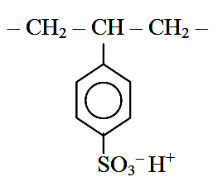
Ion-exchange resins are insoluble, cross linked, long chain organic polymers with micro porous structure. Functional groups attached to the chains are responsible for ion exchanging properties. Resins containing acidic functional groups (-COOH, -SO₃H, etc.) are capable of exchanging their H⁺ ions with other cations, which comes in their contact; whereas those containing basic functional groups (-NH₂, =NH as hydrochloride) are capable of exchanging their anions with other anions, which comes in their contact.
The ion exchange resins may be classified as:
- Cation exchange resins (RH⁺): They are mainly styrene-divinyl benzene copolymers, which on sulphonation or carboxylation, capable of exchange their hydrogen ions with cations in water.
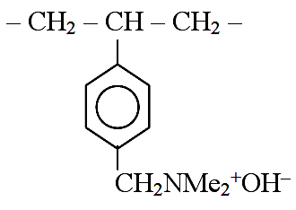
(ii) Anion exchange resins (R’OH–): They are styrene-divinyl benzene or amine formaldehyde copolymers, which contain amino or quaternary ammonium or quaternary phosphonium or tertiary sulphonium groups as integral part of resin matrix. These, after treatment with dil. NaOH solution, become capable of exchange their OH– ions with anions in water.

Ion-Exchange Softener
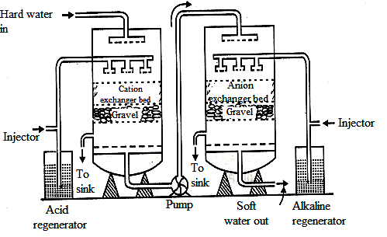
Process
Hard water is passed first through cation exchange column, which removes all cations like Ca²⁺, Mg²⁺, etc. from it, equivalent amount of H⁺ ions are released from this column to water.
RH⁺+Ca²⁺ R₂Ca²⁺ + 2 H⁺
After cation exchange column, hard water is passed through anion exchange column, which removes all anions like SO₄²⁻, Cl⁻, etc. present in water and equivalent amount of OH⁻ ions are released from this column.
ROH⁻ + Cl⁻ R’Cl⁻ + OH⁻
H⁺ and OH⁻ ions (released from cation exchange and anion exchange columns respectively) get combined to produce water molecule.

H⁺ + OH⁻ H₂O
Thus, water coming out from the exchanger is free from cations as well as anions. This ion-free water, is known as deionised or demineralised water.
Regeneration
When capacities of cation and anion exchangers to exchange H⁺ and OH⁻ ions respectively are lost, they are then said to be exhausted. The exhausted cation exchange column is regenerated by passing a solution of dil. HCl or dil. H₂SO₄. The regeneration can be represented as,
R₂Ca²⁺ + 2 H⁺ 2 RH⁺ + Ca²⁺
The column is washed with deionised water and washing (which contains Ca²⁺, Mg²⁺, etc. and Cl⁻ or SO₄²⁻ ions) is passed to sink or drain. The exhausted anion exchange column is regenerated by passing a solution of dil. NaOH. The regeneration can be represented as,
R’₂ SO₄²⁻ + 2 OH⁻ 2 R’OH⁻ + SO₄²⁻
The column is washed with deionised water and washing (which contains Na⁺ and SO₄²⁻ or Cl⁻ ions) is passed to sink or drain. The regenerated ion exchange resins are then used again.

Advantages
(i) This process can be used to soften highly acidic or alkaline waters.
(ii) It produces water of very low hardness (2 ppm). So it is very good for treating water for use in high pressure boilers.

Disadvantages
(i) This equipment is costly and more expensive chemicals are needed.
(ii) If water contains turbidity, then output of the process is reduced. The turbidity must be below 10 ppm. If it is more, it has to be removed first by coagulation and filtration.
10. Explain Electro dialysis process. (Jan 11, May 11, May 12, May 13, Jan 14, Nov 17, May 19, Nov 19)
In Electro dialysis process ions are pulled out of salt water by passing direct current, using electrodes and thin rigid plastic membrane pair. Electro dialysis cell
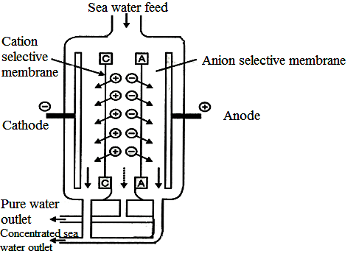
Principle
When direct current is passed through saline water, sodium ions, (Na⁺) start moving towards negative pole (cathode) while chloride ions (Cl⁻) start moving towards to the positive pole (anode) through the membrane. As a result, concentration of brine decreases in the central compartment; while it increases in two side compartments.
Desalinated brine (pure water) is removed from the central compartment from time to time; while concentrated brine (in the side compartments) is replaced by fresh brine/sea water.
Ion selective membrane
For more efficient separation, usually, ion-selective membranes are employed. An ion-selective membrane has permeability for only one kind of ions with specific charge.
For example, a cation-selective membrane is permeable to cations only, because of charged fixed functional groups, reject anions. Similarly, anion-selective membrane has positively charged fixed functional groups.
Process
An Electro dialysis cell consists of a large number of paired sets of rigid plastic membranes. Saline water is passed under a pressure of above 5 to 6 kg/m² between membrane pairs and an electric field is applied perpendicular to the direction of water flow.
Just as magnets of like charges repel each other, the fixed positive charges inside the membrane repel positively charged ions (Na⁺), yet permit negatively charged ions (Cl⁻) to pass through. Similarly in the fixed negative charges inside the other type of membrane repel negatively charged ions (Cl⁻) yet, permit positively charged ions (Na⁺) to pass through.
Therefore, water in one compartment of the cell is deprived of its salts: while salt concentration in adjacent compartment is increased. Thus, we get alternate streams pure water and concentrated brine.
Advantages
- It is most compact, cost of plant and its operation is economical.
- If electricity is easily available, it is best suited.
11. Explain Reverse Osmosis (RO) process. (Nov 11, May 14, May 16, Nov 16, May 18, Nov 18, Sep 20)
Principle
When two solutions of unequal concentrations are separated by a semi-permeable membrane; flow of solvents takes place from dilute to concentrated sites, due to osmosis. If however, a hydrostatic pressure in excess of osmotic pressure is applied on concentrated side, solvent flow reverse, i.e., solvent is forced to move from concentrated side to dilute side across the membrane.
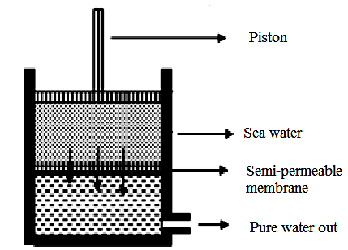
Thus, in reverse osmosis method, pure solvent (water) is separated from its contaminates, rather than removing contaminates from water. This membrane filtration is sometimes called super filtration or Hyper filtration.
Reverse osmosis cell
Method
In this process, a pressure of 15 to 40 Kg/cm² is applied to sea water/ impure water to force its pure water out through semi permeable membrane; leaving behind the dissolved solids (both ionic as well as non-ionic).
The membrane consists of very thin films of cellulose acetate, affixed to either side of a perforated tube. Recently, superior membranes made of polymethacrylate and polyamide polymers have come into use.
Advantages
- Reverse osmosis possesses a distinct advantage of removing ionic and non-ionic, colloidal and high molecular weight organic matter.
- It removes colloidal silica, which is not removed by demineralization.
- Maintenance cost is almost entirely on the replacement of semi-permeable membrane.
- Life time of membrane is quite high which is about 2 years.
- Membrane can be replaced within a few minutes, thereby providing nearly uninterrupted water supply.
- Due to low capital cost, simplicity, low operating cost and high reliability, the reverse osmosis is gaining ground at present for converting sea water into drinking water and for obtaining water for very high-pressure boilers.
12. Calculation of hardness (Jan 16, May 16, Nov 17, May 18, May 19, Sep 20)
A sample of water contains the following dissolved salts: Mg(HCO₃)₂ = 41 mg/l, CaCl₂ = 85 mg/l, MgCl₂ = 36 mg/l, CaSO₄ = 28 mg/l. Calculate temporary (carbonate) hardness, permanent (non-carbonate) hardness and total hardness of water.
It is necessary to convert values of hardness in terms of CaCO₃ equivalent.

Hardness  substance | Molecular weight | Amount of hardness substance (mg/l) | CaCO₃ equivalent  (mg/l)
Mg(HCO₃)₂  CaCl₂  MgCl₂  CaSO₄ | 146  111  95  136 | 41  85  36  28 | 41 x 100 / 146 = 28.08  85 x 100 / 111 = 76.58  36 x 100 / 95 = 37.89  28 x 100 / 136 = 20.59
Temporary (carbonate) hardness = due to [Mg(HCO₃)₂ + Ca(HCO₃)₂]
= 28.08 ppm
Permanent (non-carbonate) hardness
= due to [CaCl₂ + CaSO₄ + MgCl₂ + MgSO₄]
= 76.58 + 37.89 + 20.59
= 135.06 ppm
Total hardness = Temporary hardness + Permanent hardness
= 28.08 + 135.06 = 163.14 ppm

13. 50 ml of sample hard water required 35 ml of 0.01 M EDTA in the titration. 50 ml of same sample of water after boiling required 12 ml of 0.01 M EDTA. Calculate total and temporary hardness. (May 14, May 16, Jan 16, Nov 18, May 19, Nov 19)
50 ml of water sample = 35 ml of 0.01 M-EDTA
= (35 x 1000)/50 ml of 0.01 M-EDTA
= 700 ml of 0.01 M-EDTA
= 2 x 700 ml of 0.01 N-EDTA (Since, Normality = 2 x Molarity)
= 1400 ml (or 1.4 L ) of 0.01 eq CaCO₃
≡ 1.4 x 0.01 x 50 g CaCO₃ eq
Hence, total hardness = 0.7 g or 700mg of CaCO₃ eq
= 700 mg/L or 700 ppm
Now 50 ml of boiled water = 12 ml of 0.01 M-EDTA
1000 ml of boiled water = (12 x 1000) / 50 ml of 0.01 M-EDTA
= 240 ml of 0.01 M-EDTA
= 2 x 240 ml of 0.01 N-EDTA
= 480 ml (or 0.48 L ) of 0.01 eq CaCO₃
= 0.48 x 0.01 x 50 g CaCO₃ eq
Hence, permanent hardness = 0.24 g or 240 mg of CaCO₃ eq
= 240 mg/L or 240 ppm
Total hardness = Permanent hardness + Temporary hardness
Temporary hardness = (700-240) ppm = 460 ppm

14. On analysis, following results were obtained: MgCl₂ = 19 mg/l, CaSO₄ = 6.8 mg/l, Mg(HCO₃)₂ = 14.6 mg/l, MgSO₄ = 12 mg/l & NaCl = 2.4 mg/l.
(i) Calculate amount of lime and soda required for 25,000 litres of hard water.
(ii) If purity of lime is 90% and that of soda is 85%, calculate lime and soda required.
(iii) If cost of lime is Rs.40 and that of soda is Rs.120, calculate total cost of chemicals used for treating the hard water. (May 16, 19)
It is necessary to convert the hardness in terms of CaCO₃ equivalent. NaCl do not impact any hardness, so they do not require lime and soda.
Hardness  causing salt | Molecular weight | Amount of hardness (mg/l) | CaCO₃ equivalent  (mg/l)
MgCl₂  CaSO₄  Mg(HCO₃)₂  MgSO₄ | 95  136  146  120 | 19  6.8  14.6  12 | 19 x 100 / 95 = 20  6.8 x 100 / 136 = 5  14.6 x 100 / 146 = 10  12 x 100 / 120 = 10
(i) Lime required/litre = 74 / 100 [temp Ca²⁺ + 2 temp Mg²⁺ + perm Mg²⁺]
= 74 /100 [0 + (2 x 10) + 30]
= 74 / 100 [50] = 37 mg/l
Lime required for 25,000 litre of hard water
= 25,000 litre x 37 mg/l = 0.925 kg
Soda requirement = 106 / 100 [perm Ca²⁺ + perm Mg²⁺]
= 106 / 100 [5 + 30] = 37.1 mg/l
Soda required for 25,000 litres of hard water
= 25000 litre x 37.1 mg/l = 0.927 kg
(ii) Purity of lime is 90%
90 kg of lime is present in 100 kg of impure sample
0.925 kg of lime present in = 100 / 90 x 0.925 = 1.027 kg
Purity of soda is 85%
85 kg of soda is present in 100 kg of impure sample
0.927 kg of soda present in = 100 / 85 x 0.927 = 1.09 kg
(iii) 1 kg of 90% impure lime = 50 rupees
1.027 kg of impure lime = 1.027 x 50 = Rs. 51.35
1 kg of 85% impure soda = 120 rupees
1.09 kg of impure soda = 1.09 x 120 = Rs. 130.80
Total cost of chemicals used for 25000 litres of hard water
= Rs. 51.35 + Rs. 130.80 = Rs. 182.15

